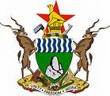

THE CURRENT USE OF MOBILE TECHNOLOGY FOR DATA COLLECTION SITUATIONAL STUDY REPORT AND ANALYSIS

JANUARY 2015

Collaborating partners
MINISTRY OF LOCAL GOVERNMENT PUBLIC WORKS AND NATIONAL HOUSING ZIMBABWE NATIONAL STATISTICS AGENCY (ZimStat)
RESEARCH AND INFORMATION SERVICES (RIS)

Acknowledgements
We would like to thank the following for making this project a success;
- United Nations Economic Commission for Africa (UNECA),
- Zimbabwe National Statistical Agency (ZimStat),
- Ministry of Local Government, Public Works and National Housing Zimbabwe,
- Ministry of Health and Child Care Zimbabwe,
- Ministry of Transport and Infrastructural Development Zimbabwe,
- Ministry of Primary and Secondary Education Zimbabwe,
- International Governmental Organisations,
- International Non-Governmental Organisations, Community Based Organisations; and Faith based organisations.

Acronyms
ZimStat Zimbabwe National Statistics Agency
UNECA United Nations Economic Commission for Africa
RIS Research and Information Services
UMTFDC – Use of Mobile Technology for Data Collection
MTFDC Mobile Technology for Data Collection
UNICEF United Nations Children’s Fund
CRS Catholic Relief Services
FACT Family AIDS Caring Trust

Introduction
The Zimbabwe National Statistics Agency (ZimStat) in collaboration with the Ministry of Local Government, Public Works and National Housing (MoLGPWNH) and Research and Information Services (RIS) with financial and technical support from the United Nations Economic Commission for Africa (UNECA) is implementing a pilot project in Mudzi District of Mashonaland East Province, Zimbabwe on the use of mobile technology to collect data for development. In line with the pilot project, the partner organisations did a situational analysis study on the current status of the use of mobile technologies for data collection in Zimbabwe. The study prompted the writing of this report as it invites readers to explore the topic, findings, results and conclusions
This situational analysis study aimed at:
- identifying the actors (governments, international organisations, NGOs, businesses, etc.) engaged in the use of mobile technology in data collection
- documenting lessons learnt from counterpart’s experiences in all facets of the process from hardware and software used to management of the data collection process from enumerator with handheld device to data utilisation and dissemination
- mapping and analysing various activities involving the collection of data, constraints and the context in which these activities take place and tools currently in use either on the mobile platform or elsewhere
- examine the coverage of mobile network infrastructure in Zimbabwe

Background and Context
Making data available to organisations faster and easier reduces decision time and in turn enhances timely response to problems. Data can only be made available to organisations faster by using mobile technology. Mobile phone based data collection systems typically have several components that communicate for data collection, transmission, storage and retrieval. These include portable computers, notebooks, tablets, mobile phones especially smartphones . There are over 6 billion mobile phone subscribers and 75% of the world has access to a mobile phone . This creates opportunities to use mobile phones to capture data at the source, thus removing significant sources of data quality problems usually associated with manual transfer of data from paper to computer for processing. Good data on children vaccination coverage, number of people in an area, school enrollment, access to health facilities etc. allows government and development partners to accurately plan, budget, and evaluate their activities .

The 21st Century has witnessed rapid technological advancement and in line with such developments, mobile phones are being used in data collection. Mobile Data Collection (MDC) is the targeted gathering of structured information using devices such as smartphones, PDAs, or tablets. In the last few years, in addition to continuous improvements of earth-observation and web mapping techniques, the increasing use of new sources of geo-information based on new mobile technologies has emerged. This has created insights and opportunities into the mechanisms of sudden onset crisis related data collection, analysis and mapping. The high mobile phone penetration rates in developing countries are transforming how data collection is conducted. Mobile phones are replacing paper-based surveys offering several benefits including, reduced cost, increased reach, short-turnaround times, and better data accuracy . Mobile technology can be used for a variety of applications including: health; education; agriculture, livelihoods, poverty alleviation, the environment and disasters
The speed and magnitude at which connectivity is and mobile technology has spread in the developing world are startling. Globally, the number of mobile phone subscribers has grown from 1 billion in 2000 to over 6 billion in 2012, of which nearly 5 billion are in developing countries . Even in some of the poorest developing countries, more than 90% of households own a mobile phone and adoption is increasing fast. These developments have coincided with the need for better data which is more urgent in most African countries, where data improvements have been sluggish .
Zimbabwe has also witnessed a high mobile penetration almost following the global trends. According to the Postal and Telecommunications Regulatory Association of Zimbabwe (POTRAZ) fourth quarter report 2013, the total number of mobile subscriptions increased from 13,518,887 recorded at the end of the third quarter of 2013 to reach 13,663,167 subscribers at the end of December 2013. This implies a net addition of 114,280 subscriptions, representing a marginal growth of 0.9%. This also reflects a year-on-year growth of 8.1% from 12,613,935 subscribers recorded in the 4th quarter of 2012.
- The internet penetration rate increased by 2.1% to reach 41.9% from 39.8% recorded in the previous quarter
- Data and internet subscribers increased by 5.2% to reach 5.5 million from 5.2 million subscribers recorded in the previous quarter
This evidence buttresses that the use of phones and technology is undoubtedly on the rise in Zimbabwe. In the wake of such positive changes, people are engaging the use of mobile technology for data collection as a way to do away with paperwork and its disadvantages.

Methodology
- Purpose of Survey
The purpose of this situational analysis was to document lessons learnt from the counterpart’s experiences in the use of mobile technology for data collection. The survey was to get their experiences in all facets of the process from hardware and software used for management of data collection from enumerator with hand held devices to data utilization and desermination.
The analysis was to serve to establish benchmarks as well as develop effective national partnerships for the implementation of the project. It was also to examine the existence of available skill sets in counterpart organisations and the coverage of mobile network and infrastructure among others.
- Sample size
A total of twenty (20) organisations/entities/samples participated in the survey administered by Zimbabwe National Statistics Agency (ZimStat) from the participation base, ZimStat used in this survey report, a total of thirteen (13) responses.
- Distribution Dates/Mode of Survey
The study conducted a series of interviews with people and organisations involved in data collection activities using mobile technologies. The semi-structured questionnaires were distributed and collected either after some hours or after a day depending on the physical location of the respondent. Further clarifications were made if the responses were not clear.
The questionnaire was exclusively available in both hard copies and soft copies at Research and Information Services (RIS) offices and later distributed to the selected respondents during the survey period. The questionnaire contained 17 questions (appendix 1).

- Return Rate
The Use of Mobile Technology for Data Collection (UMTFDC) analysis overall survey return rate was 72.2%.

SAMPLING
The study used subjective sampling technique/method. The study identified specific governmental departments and non-governmental organizations. Respondents were drawn out of these specific organisations. The main goal of this sampling method was to focus on particular characteristics of a population that are of interest, which will best enable us to answer the research questions that we had.
The aim was to get a synopsis of the use of mobile technology for data collection from a wide spectrum of organizations including; government departments (Ministry of Health and Child Welfare, Ministry of Primary and Secondary Education, Ministry of Local Government, Public Works and National Housing), International Governmental Organisations, (United Nations Children’s Fund (UNICEF), International Non-Governmental organisations (Plan International, Care International, JF Kapneck Trust), community based organisations ( Family AIDS Caring Trust (FACT), Restless Development), Faith based organisations (Catholic Relief Services (CRS).
The major justification being that the above mentioned organisations are found all over the country, have structures all over Zimbabwe and are represented at the lowest levels in the communities. So a picture from these entities is likely to give us the current state of data collection using mobile technology in Zimbabwe.

Results
- Our results show that 92.3% of the respondents have used mobile technology for data collection.
- We also found that 7.6 % have not used any mobile technology for data collection. The results of our analysis are illustrated on fig 1.
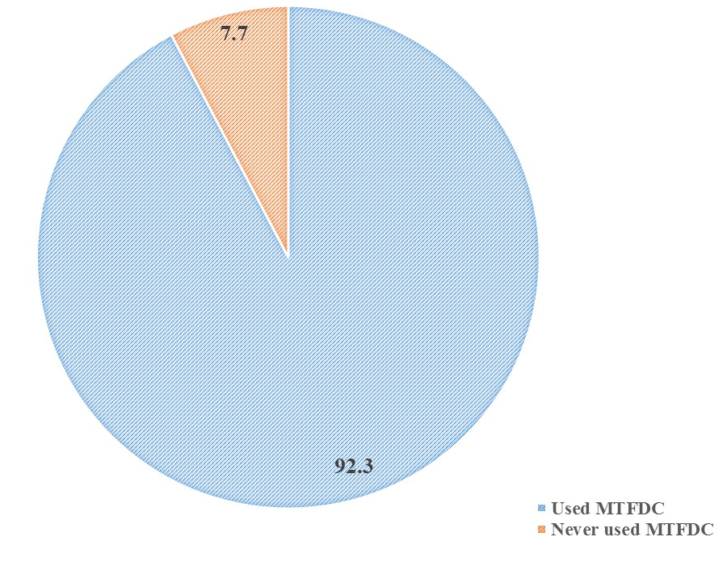
Figure 1: Percentage of participants who have use MTFDC against those who have never used it.

- Out of the 92.3% respondents who have used mobile technology for data collection, 41, 6 % of the respondents are still using mobile technology for data collection
- Of the 92.3% of the respondents who have used mobile technology for data collection, 41.6 % have used or are using the technology countrywide (including in Mudzi).
- At least 53.8% of the respondents who used mobile technology for data collection have been using internal enumerators for the data collection.
- Those that have been using external enumerators amounted to 15.3% of the total number of the participants who have used mobile technology for data collection as indicated in Fig 2.
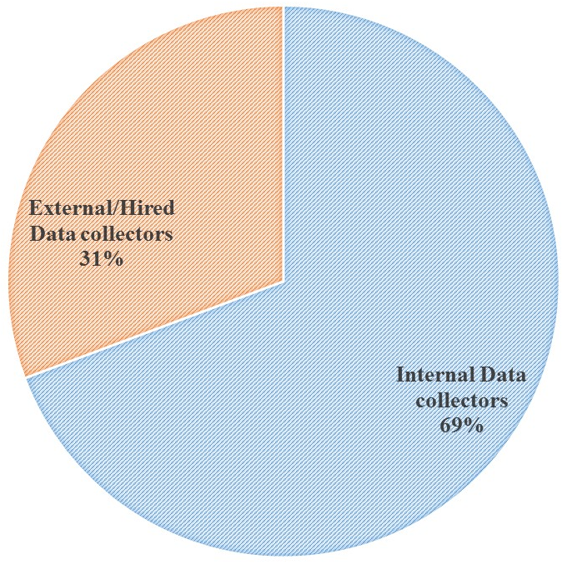
Figure2: Percentage of participants using different data collectors
g) Those that have been using both internal and external enumerators were 30.7 % of the total number of participants who used mobile technology for data collection.

FACTS TO NOTE
- Zimbabwe is experiencing a growth in the use of mobile technology for data collection. From the study, the use of mobile technology in data collection is growing steadily from the year 2010 to 2014. Fig 3 highlights the growth of use of mobile devices for data collection according to our findings.
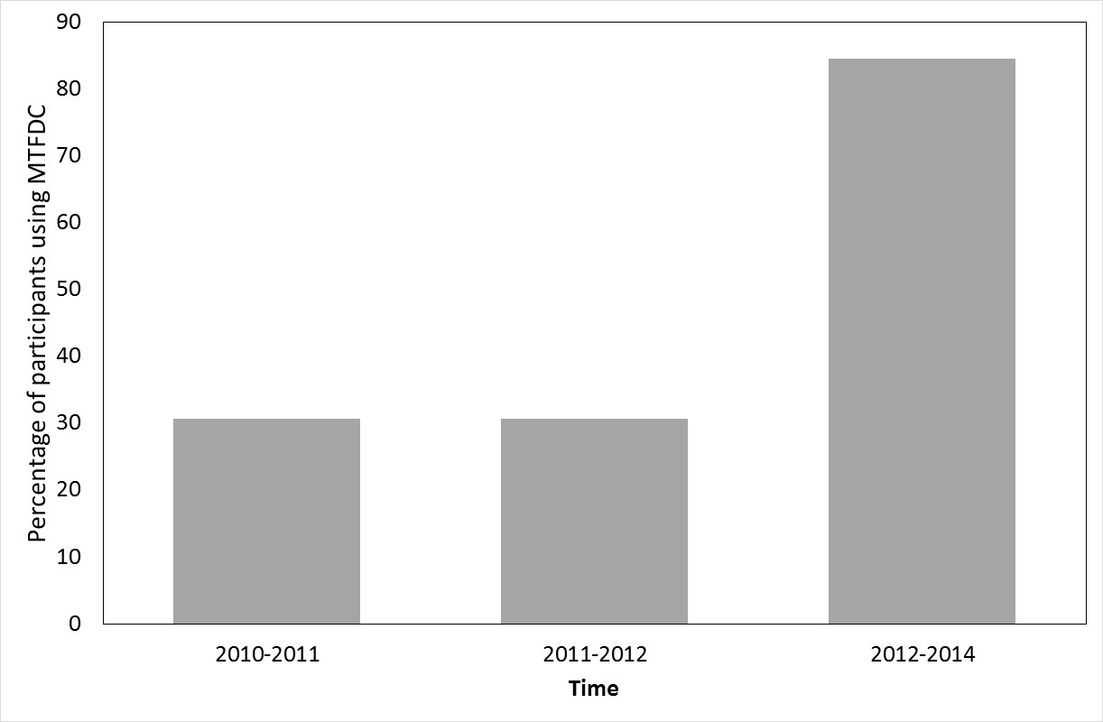

Figure 3: Percentage of participants who have been using MTFDC
As noted in fig 3, from the year 2010-2011, the number of organisations using mobile technology for data collection was 30.7%. The number remained like that for the time of 2011-2012, at 30.7%. From 2012-2014 the total percentage of organisations who have used mobile technology for data collection sharply rose to 84.6 % of our total samples. Therefore, it can be stated that, there was an abrupt rise in the use of mobile technology for data collection in Zimbabwe.
- Most respondents have been using mostly open source software for data collection. Open-source Software like Native Development Kit (NDK), Open Data Kit (ODK and Epi Surveyor were used by some organisations for data collection. On the contrary, some organisations like Care International used CSPro, iForm Builder and other own built Applications for data collection.
- One major observation is the use of internal enumerators for data collection in communities. Of the 92.3% of respondents who have used mobile technology for data collection, 53.8% have been using their own (internal) enumerators to collect data. This compromises on the sustainability part of their programmes, a reason that could explain why some of their programmes collapsed later as time progressed. As highlighted by some respondents, some people feel insecure when an outsider comes in to record information using mobile devices and this will in some way affect the authenticity of the collected data.
- Data transmission was not regular and updated regularly. 75% of the respondents cited that they were using data transmission cabled and flash drives to store and exchange data thus making the data prone to viruses and corruption. This way of data transmission also has problems of those flash drives unable to handle loads of data and this determines how far one can get in collecting the data.

Challenges
The participants cited the following as the challenges they faced during data collection using mobile technologies of their choices,
- The main challenge remains to identify the appropriate mobile data collection system to fit the multiplicity of operational contexts humanitarian organizations have to operate in.
- The second challenge is to keep track of the evolution of a very dynamic sector and the constant evolution of new technologies flourishing on the data collection market.
- While the rich content of information - whether available on the internet or in the data derived from mobile data collection - poses opportunities for application in crisis management, it also poses challenges derived from the analysis of the quality, accuracy, and reliability of the data.
- Data connectivity: even if they are designed to work offline, applications need to be connected to the organisation (over the internet, or physically) in order to send back results. It is very important that the agent is, at some point, able to connect. Often, the necessity to travel far to reach such connectivity is a major barrier.
- Equipment: even if the price of smart phones is currently decreasing, it remains prohibitive, and is only part of other costs associated with this approach: the logistics of delivering, dispatching and maintaining the devices, as well as the cost of training the agents to use new and complex devices. This makes it very unlikely that one‐off data collection exercises (e.g., censuses) can be done successfully using this scenario, and many examples of failure exist.
- The cost of communication (messaging or calling) is a burden to the respondents since they normally initiate sending the data. Toll-free numbers or compensation is usually the way to solve this specific issue.
- Even if the respondent can read and is familiar with mobile phones, most cases require some training, either learning a specific syntax for SMS responses, or familiarizing oneself with the menu structure of an IVR.
- Literacy is also a parameter to take into account, especially in rural areas: sending an SMS, or even dialing a call, can be difficult to some respondent, if possible at all
- Some choices of PDAs were not functioning well
- Enumerators were not properly trained so there was need for onsite data verification even after the initial data collection exercise.
- Due to lack of electricity in some rural areas, charging batteries for the devices was a challenge as indicated by one participant.
- To those who were transmitting data using data cables and flash drives, they cited incidences of data becoming corrupt or viral attack as major challenges that affected the whole process.

Recommendations from the participants
- There is need for thorough extensive training of personnel and pre testing of gadgets and software before using them. Some respondents highlighted the incidences of PDA’s sticking, running out of power and facing some minor technical problems
- Use of external enumerators’ especially local enumerators will surely ensure openness on the part of the people whose details are being collected. The local people are likely to cooperate and be associated with the programme if one of them is at the helm of data collection. This will in turn at least contribute to accurate data or to near accurate data.
- The respondent’s perception of the exercise, and the trust they put in it, are also essential to run an accurate data collection exercise. The most notable parameter is the perception of cost, in the cases where the respondent initiates calls or SMS messages. Trust must be established that the operation is not a scam, and that whatever channel they use will be free. The safest technological choices in that respect are USSD, widely considered free, and IVR call-back (triggered by the respondent flashing a number). For normal call-in, or SMS, it can be difficult to convince respondent that they will not have to pay, especially in areas where Phone/SMS scams are common.
- There should be simpler applications with other functionalities as most of the applications do not support database capabilities but only text data
- It is imperative to provide mobile power banks or some form of mobile battery charging to keep the process of data collection ongoing and get accurate data.
- Awareness of available technology does not easily lead to its adoption; hence there is need for organizations to identify their current programmes and pilot the technology to see how it can best work for the organization (step by step approach).

CONCLUSION
Mobile technology has been termed ‘the single most transformative technology’ for development. Mobile technology especially cell phones have a positive and significant impact on improving the speed and efficiency of data collection and monitoring. From our study, on mobile technology for data collection in Zimbabwe, it is clear that the use of mobile technology offers great opportunities the country to utilise it for development. To successful use mobile technology in data collection there is need to make the technology acceptable by its intended beneficiaries. We further conclude that data collection using mobile technology needs to be done by well-known people in their respective communities for sustainability purposes. These people should therefore be properly trained to do so for data authenticity, enough support should be given to these people for them to continue carrying out data collection exercises. In addition, there is need for continued expansion of network services in rural areas for successful data collection using mobile technologies if that means data should be updated regularly and more effort and support is needed on strengthening the initiative of data collection using mobile devices since most organisations and government departments that formed this study samples indicated their desire to partner with whoever is into data collection using mobile devices.

References
Akinfaderin-Agarau, F., M. Chirtau, S. Ekponimo, and S. Power. 2012. Opportunities and Limitations for Using New Media and Mobile Phones to Expand Access to Sexual and Reproductive Health Information and Services for Adolescent Girls and Young Women in Six Nigerian States. African Journal of Reproductive Health 16:219-230.
CGD. 2014. Delivering on the data Revolution in Sub-saharan Africa. Washington, DC.
Free, C., G. Phillips, L. Felix, L. Galli, V. Patel, and P. Edwards. 2010. The effectiveness of M-health technologies for improving health and health services: a systematic review protocol. BMC Research Notes 3:2-7.
Ganesan, M., S. Prashanta, and A. Jhunjhunwala. 2012. A Review on Challenges in Implementing Mobile Phone Based Data Collection in Developing Countries. Journal of Health Informatics in Developing Countries 6:366-374.
Tomlinson, M., M. J. Rotheram-Borus, L. Swartz, and A. C. Tsai. 2013. Scaling Up mHealth: Where Is the Evidence? PLoS Med 10:e1001382. doi:1001310.1001371/journal.pmed.1001382.

Appendix 1.
Situational Analysis on the Current Status of the Use of Mobile Technology for Data Collection in Zimbabwe Questionnaire

SECTION A
- Name of Organisation…………………………………………….………………………..
- Name of Respondent…………………………..……………………………………………
- Position in the organisation………………………………………………………………..
- Have you ever used mobile technology to collect data for development: (Yes/No)……….
If YES,
- Where (Area(s))...……………………………………………………………..……………
- When (Period)…………………………………………………………………..…………
- For what purpose did you collect the data using this technology....………………..……..
………………………………………………………………………………………………..
…………………………………………………………………………...……………………
- Who collected the data (staff members or hired enumerators) ….…………………………
- What is the nature of the data that was collected (Quantitative, Qualitative or both)………………………………………………………………………………………..

SECTION B – DEVICE
- What type of device was used for data collection (portable laptop, tablets, PDA, cell phone, etc?)
………………………………………………………………………………………………
- What other purpose does the device serve if you are not using it for collecting data?.......................................................................................................................................
………………………………………………………………………………………………
- What operating system was used on the device Windows, Android, iOS etc?)…………
………………………………………………………………………………………………
- What data collection application was on the mobile device? (CSPro, Frontline SMS, ODK, custom-made) ………………………………………………………………………………………………………………………………………………………………………………………………
- How was data transmitted from device to central repository (via sms, internet, flash) …… ……………………………………………………………………………………………..

- What are advantages are derived from using mobile technologies for data collection…………………………………………………………………………………..
........……………………………………………………………………………………………

- What challenges are encountered in transferring data from the field via the platform that you were using?…………………………………………………………………………….
………………………………………………………………………………………………
- Are you willing to share experiences with our team working on the Data Collection using electronic village registers? Yes/No………………………………………………………..

- Do you have ongoing data collection using mobile technologies activities? Yes/No……..

SECTION C –RECOMMENDATIONS
- What lessons were learnt that could inform utilization of mobile technology in future surveys/researches of similar nature?
…………………………………………………………………………………………………………………………………………………………………………………………………………………………………………………………………………………………………………………………………………………………………………………………….

- Recommendations (based on your experience in using technology in data collection and management for development)…………………………………………………………
……………………………………………………………………………………………………………………………………………………………………………………………………………………………………………………………………………………………………………………………………………………………………………………………...

We thank you for completing this questionnaire.

